You have a class named Customer and a class named Order.  
The customer class has a property named Orders that contains a list of Order objects.  
The Order class has a property named OrderDate that contains the date of the Order.  
You need to create a LINQ query that returns all of the customers who had at least one order during the year 2005. You write the following code.

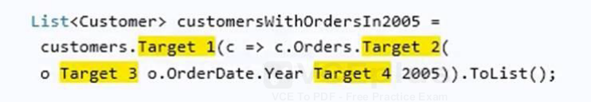

**List customersWithOrdersIn2005 = customers.Where(c => c.Orders.Any(o => o.OrderDate.Year == 2005)).ToList();**

You are building an application in Microsoft Visual Studio 2013.  
You have the following code.

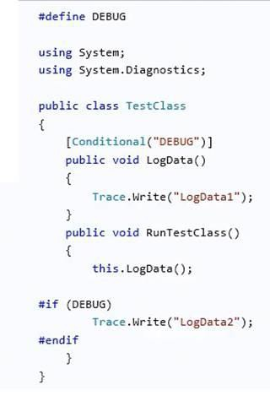**Yes, yes, yes**

You have a C# application.  
The application requires 500 MB of available memory.  
You need to identify whether there is enough available memory when the application starts.  
Which class should you use? **PerformanceCounter**

You have the following code: 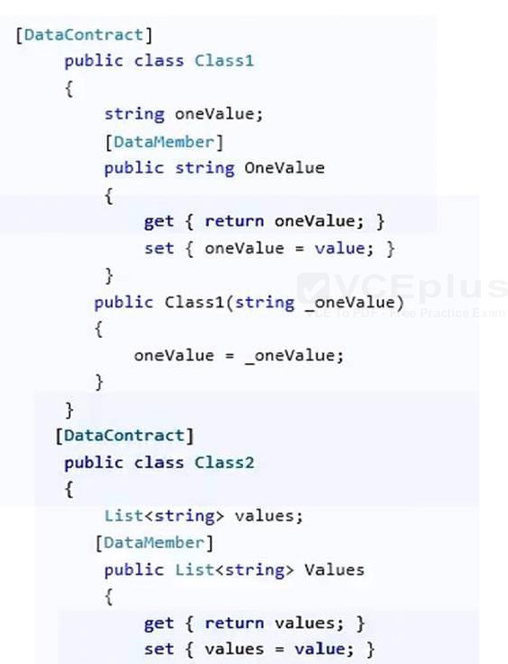

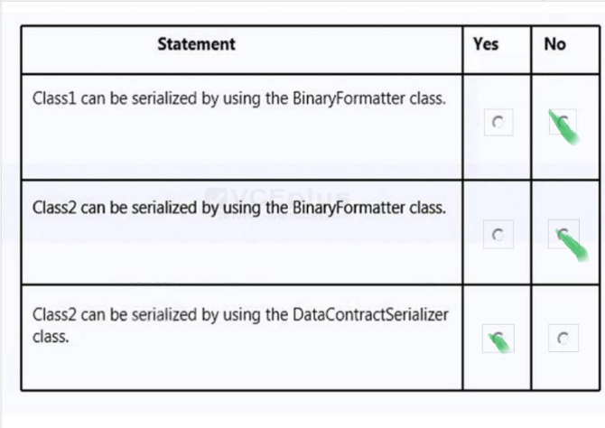

You are developing a function that takes a parameter named aParam as a string input.  
You need to convert aParam to a Double. If the conversion cannot be completed, the function should return 0

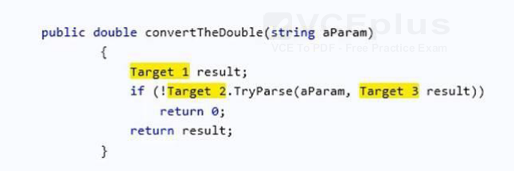

**public double convertTheDouble(string aParam)  
{  
double result;  
if (!double.TryParse(aParam, out result))  
return 0;  
return result;  
}**

You are creating a console application named Appl.  
App1 retrieves data from the Internet by using JavaScript Object Notation (JSON).  
You are developing the following code segment (line numbers are included for reference only):

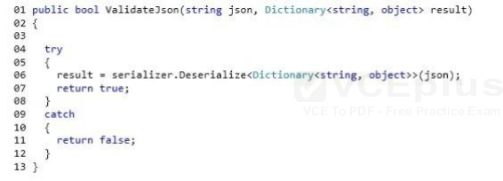

You need to ensure that the code validates the JSON string.  
Which code should you insert at line 03?

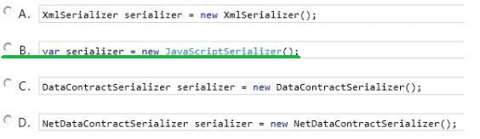

You are testing an application. The application includes methods named CalculateInterest and LogLine. The CalculateInterest() method calculates loan interest. The LogLine() method sends diagnostic messages to a console window.  
The following code implements the methods. (Line numbers are included for reference only.)

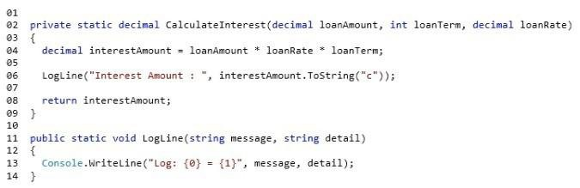  
You have the following requirements:  
The CalculateInterest() method must run for all build configurations.  
The LogLine() method must run only for debug builds.  
You need to ensure that the methods run correctly.  
What are two possible ways to achieve this goal?

**Insert the following code segment at line 10:**  
[Conditional(“DEBUG”)]

**Insert the following code segment at line 05:**  
#if DEBUG  
Insert the following code segment at line 07:  
#endif

You have a class named Customer and a variable named customers.  
You need to test whether the customers’ variable is a generic list of Customer objects.  
Which line of code should you use?

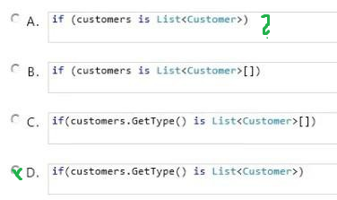

You are creating an application that reads from a database.  
You need to use different databases during the development phase and the testing phase by using conditional compilation techniques.  
What should you do? **Specify the /define compiler option.**

You have the following code.  
string MessageString = ?his is the original message!?  
You need to store the SHA1 hash value of MessageString in a variable named HashValue.  
Which code should you use? Develop the solution by selecting and arranging the required code blocks in the correct order. You may not need all of the code blocks.

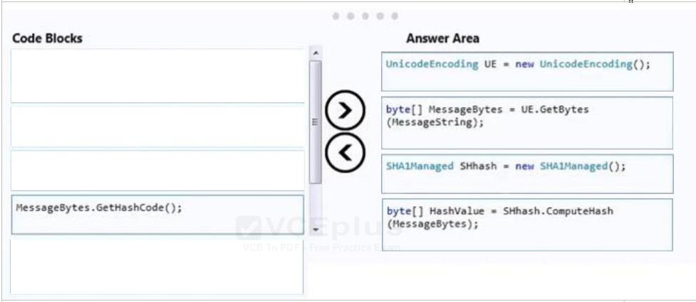

You write the following method (line numbers are included for reference only):

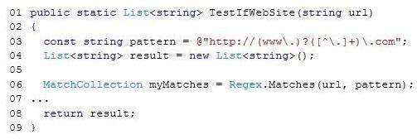  
You need to ensure that the method extracts a list of URLs that match the following pattern:  
@http://(www.)?([^.]+).com;  
Which code should you insert at line 07?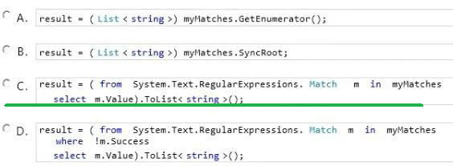

You are developing an application that implements a set of custom exception types. You declare the custom exception types by using the following code segments:

  
The application includes a function named DoWork that throws .NET Framework exceptions and custom exceptions. The application contains only the following logging methods:

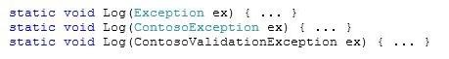  
The application must meet the following requirements:  
When ContosoValidationException exceptions are caught, log the information by using the static void Log (ContosoValidationException ex) method.  
When ContosoDbException or other ContosoException exceptions are caught, log the information by using the static void Log(ContosoException ex) method.  
You need to meet the requirements.  
You have the following code:

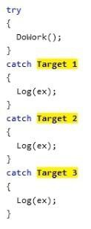  
Which code segments should you include in Target 1, Target 2 and Target 3 to complete the code? (To answer, drag the appropriate code segments to the correct targets in the answer area. Each code segment may be used once, more than once, or not at all. You may need to drag the split bar between panes or scroll to view content.)  
Select and Place: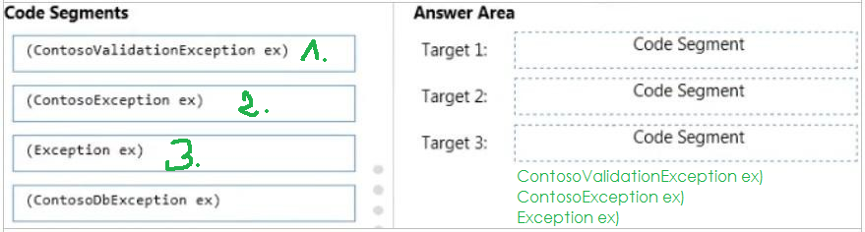

You need to write a console application that meets the following requirements:  
If the application is compiled in Debug mode, the console output must display Entering debug mode.  
If the application is compiled in Release mode, the console output must display Entering release mode.  
Which code should you use?

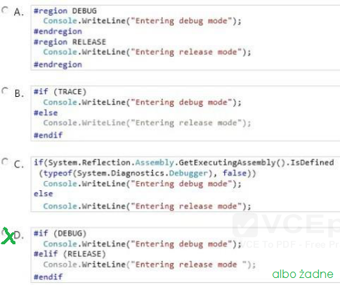

You write the following code.

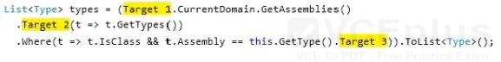  
You need to get the list of all the types defined in the assembly that is being executed currently.

**List types2 = AppDomain.CurrentDomain.GetAssemblies().  
SelectMany(t => t.GetTypes())  
.Where(t => t.IsClass && t.Assembly == GetType().Assembly).ToList<>();**

You are developing an application that includes methods named ConvertAmount and TransferFunds.  
You need to ensure that the precision and range of the value in the amount variable is not lost when the TransferFunds() method is called.  
Which code segment should you use? **Decimal**

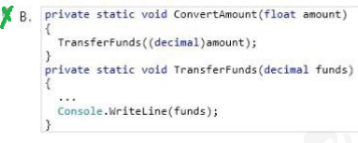

A developer designs an interface that contains the following code:

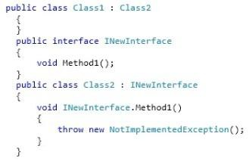

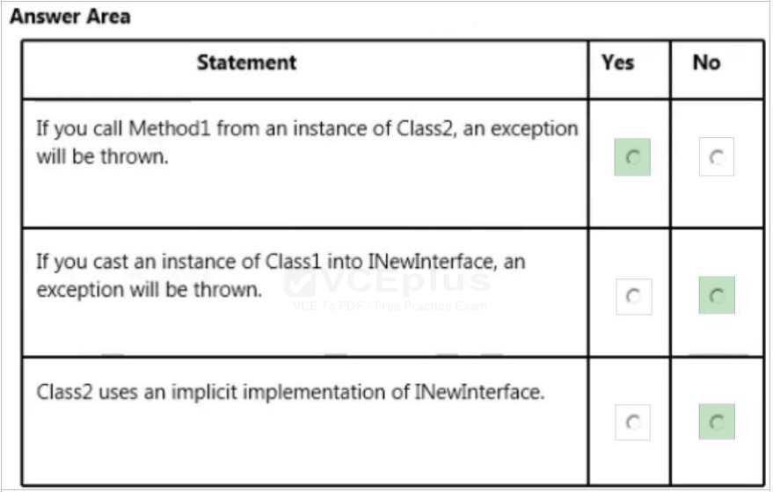

You have the following code (line numbers are included for reference only):

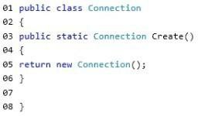  
You need to ensure that new instances of Connection can be created only by other classes by calling the Create method. The solution must allow classes to inherit from Connection.  
What should you do?

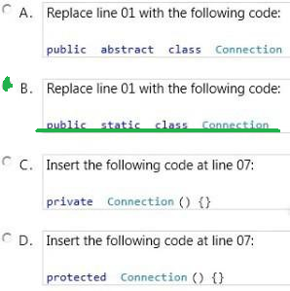

You have the following class. (Line numbers are included for reference only.)

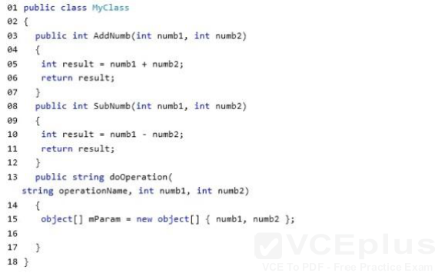  
You need to complete the doOperation method to meet the following requirements:  
If AddNumb is passed as the operationName parameter, the AddNumb function is called.  
If SubNumb is passed as the operationName parameter, the SubNumb function is called.  
Which code should you insert at line 16? Develop the solution by selecting and arranging the required code blocks in the correct order. You may not need all of the code blocks.  
Select and Place:

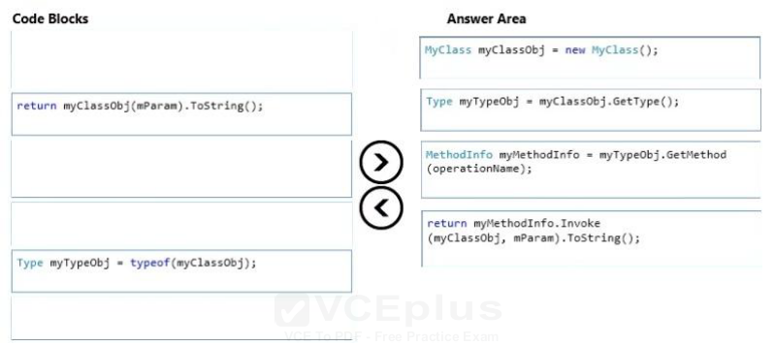

You are creating a class named Data that includes a dictionary object named _data.  
You need to allow the garbage collection process to collect the references of the _data object.  
You have the following code:

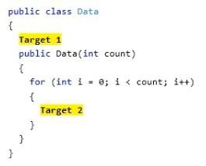  
Which code segments should you include in Target 1 and Target 2 to complete the code?

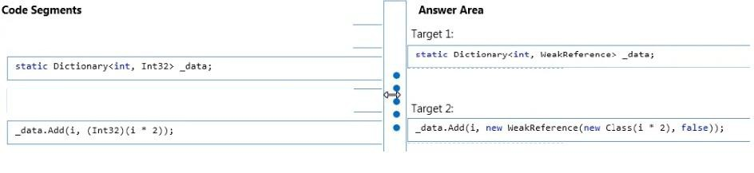

You are developing a class named Temperature.  
You need to ensure that collections of Temperature objects are sortable. You have the following code:

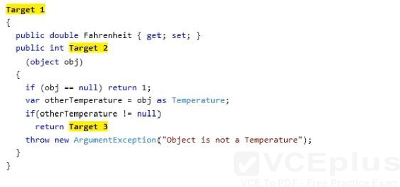  
Which code segments should you include in Target 1, Target 2 and Target 3 to complete the code?

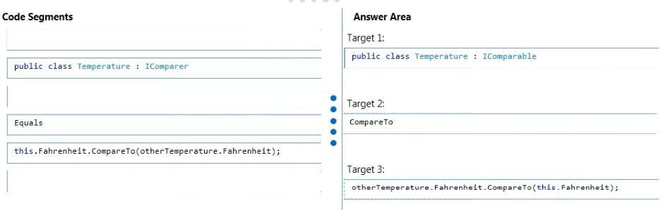

You are developing an application that contains a class named TheaterCustomer and a method named ProcessTheaterCustomer. The ProcessTheaterCustomer() method accepts a TheaterCustomer object as the input parameter.  
You have the following requirements:  
Store the TheaterCustomer objects in a collection.  
Ensure that the ProcessTheaterCustomer() method processes the TheaterCustomer objects in the reverse order in which they are placed into the collection.  
You need to meet the requirements.  
What should you do? **Create a System.Collections.Stack collection. Use the Push() method to add TheaterCustomer objects to the collection. Use the Pop() method to pass the objects to the ProcessTheaterCustomer() method.**

ou have the following code. (Line numbers are included for reference only).

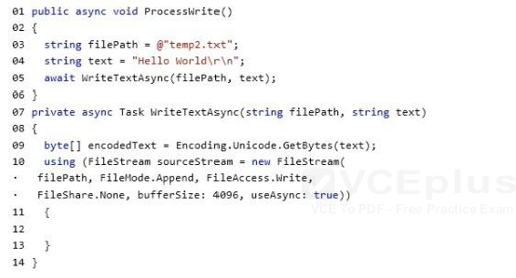  
You need to complete the WriteTextAsync method. The solution must ensure that the code is not blocked while the file is being written. Which code should you insert at line 12?

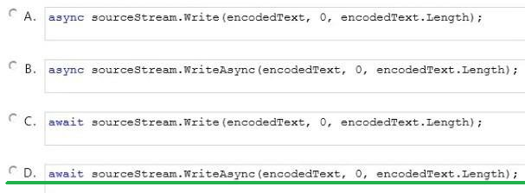

You need to write a method that retrieves data from a Microsoft Access 2013 database. The method must meet the following requirements:  
Be read-only.  
Be able to use the data before the entire data set is retrieved.  
Minimize the amount of system overhead and the amount of memory usage.  
Which type of object should you use in the method? **DbDataReader *class***

You have the following code:

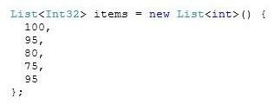  
You need to retrieve all of the numbers from the items variable that are greater than 80.  
Which code should you use?

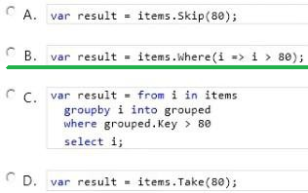

An application serializes and deserializes XML from streams. The XML streams are in the following format:

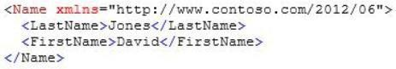  
The application reads the XML streams by using a DataContractSerializer object that is declared by the following code segment:

  
You need to ensure that the application preserves the element ordering as provided in the XML stream.  
You have the following code:

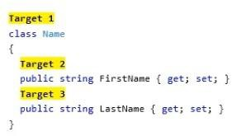  
Which attributes should you include in Target 1, Target 2 and Target 3 to complete the code? (To answer, drag the appropriate attributes to the correct targets in the answer area. Each attribute may be used once, more than once, or not at all. You may need to drag the split bar between panes or scroll to view content.)  
Select and Place:

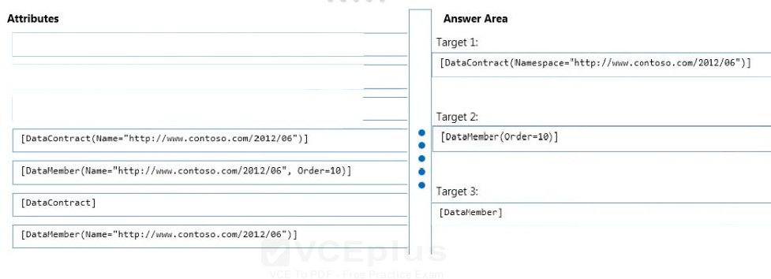

When you execute the code, you get an exception.

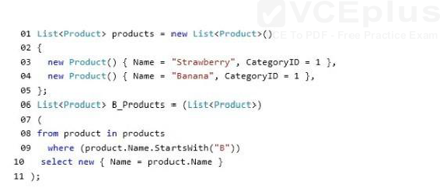  
You need to ensure that B_Products contain all of the products that start with the letter “B”.  
What should you do?

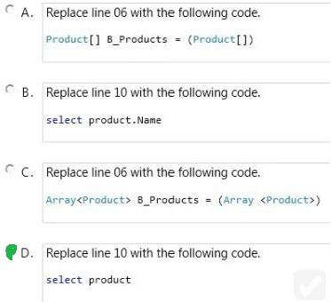

You are developing a C# application. The application includes a class named Rate. The following code segment implements the Rate class:

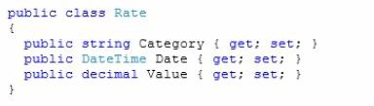  
You define a collection of rates named rateCollection by using the following code segment: CollectionrateCollection = new Collection() ;  
The application receives an XML file that contains rate information in the following format:

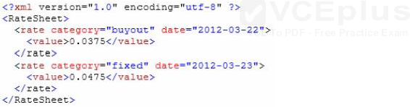  
You need to parse the XML file and populate the rateCollection collection with Rate objects.  
You have the following code:

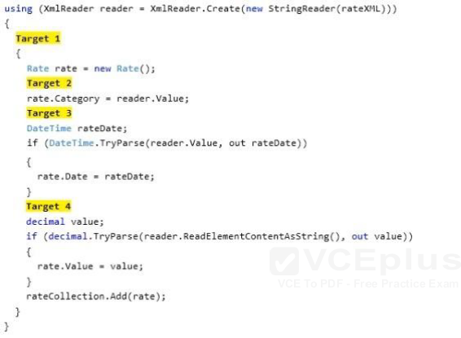  
Which code segments should you include in Target 1, Target 2, Target 3 and Target 4 to complete the code?

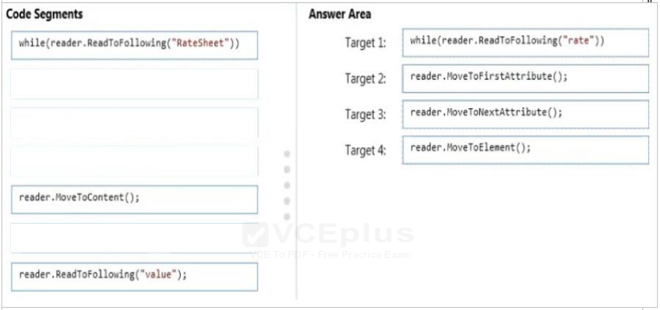

You are modifying an existing application.  
The application includes a Loan class and a Customer class. The following code segment defines the classes.

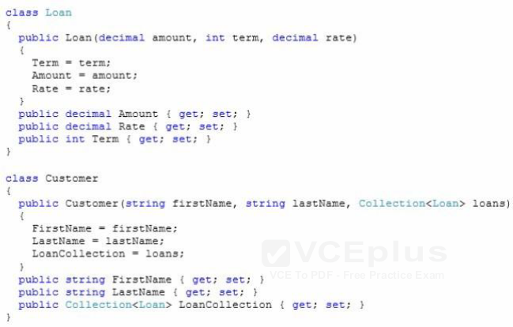  
You populate a collection named customer-Collection with Customer and Loan objects by using the following code segment:

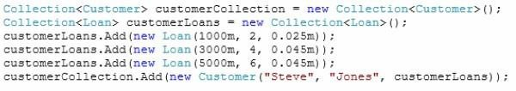  
You create a largeCustomerLoans collection to store the Loan objects by using the following code segment: Collection largeCustomerLoans = new Collection();  
All loans with an Amount value greater than or equal to 4000 must be tracked.  
You need to populate the largeCustomerLoans collection with Loan objects.  
Which code segment should you use?

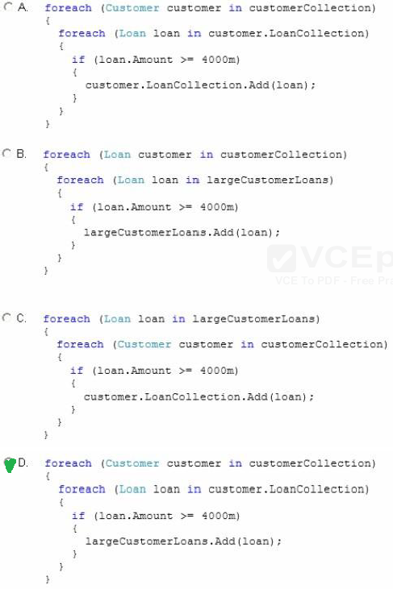

You have the following code.

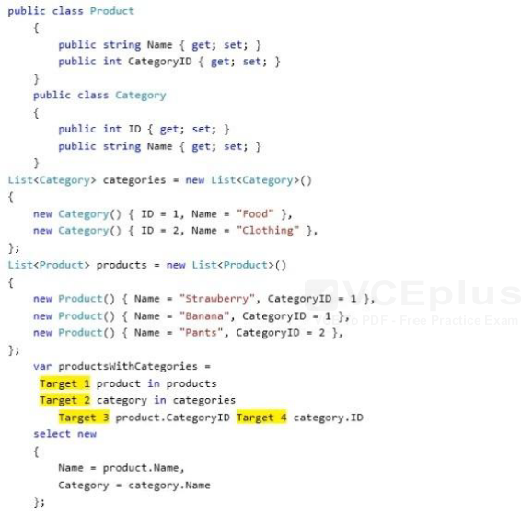  
You need to return all of the products and their associated categories.  
How should you complete the code? To answer, drag the appropriate code elements to the correct targets in the answer area. Each code element may be used once, more than once, or not at all. You may need to drag the split bar between panes or scroll to view content.

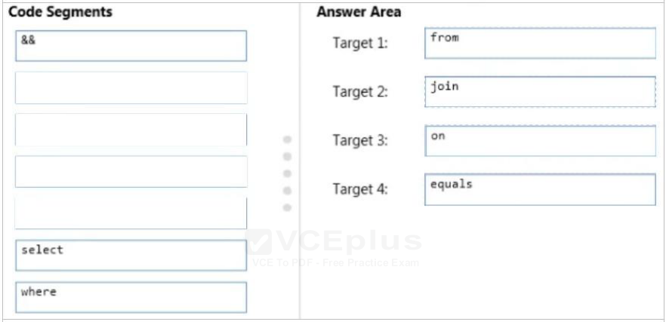

You are developing an application that will manage customer records. The application includes a method named FindCustomer.  
Users must be able to locate customer records by using the customer identifier or customer name. You need to implement the FindCustomer() method to meet the requirement.  
Which two sets of method signatures can you use to achieve this goal? (Each correct answer presents a complete solution. Choose two.)

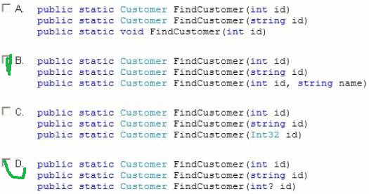

You need to write a method that combines an unknown number of strings. The solution must minimize the amount of memory used by the method when the method executes.  
What should you include in the code? **The StringBuilder.Append method**

You are implementing a method named ProcessFile that retrieves data files from web servers and FTP servers. The ProcessFile () method has the following method signature:  
Public void ProcessFile(Guid dataFileld, string dataFileUri)  
Each time the ProcessFile() method is called, it must retrieve a unique data file and then save the data file to disk. You need to complete the implementation of the ProcessFile() method. Which code segment should you use?

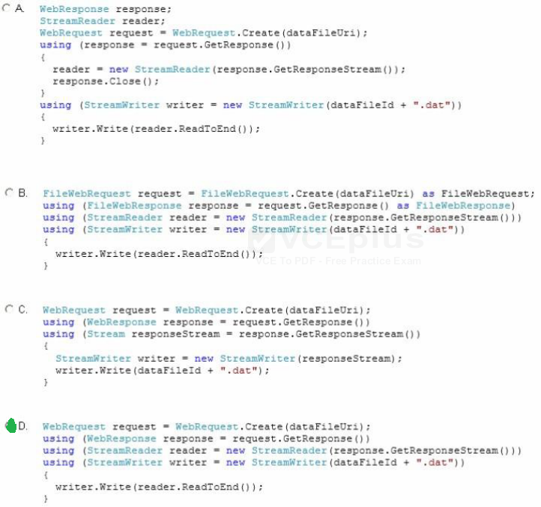

You are creating a class library that will be used in a web application.  
You need to ensure that the class library assembly is strongly named.  
What should you do? **Use assembly attributes.**

You are developing a C# application. The application includes a class named Rate. The following code segment implements the Rate class:

  
You define a collection of rates named rateCollection by using the following code segment: CollectionrateCollection = new Collection() ;  
The application receives an XML file that contains rate information in the following format:

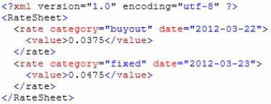  
You need to parse the XML file and populate the rateCollection collection with Rate objects.  
How should you complete the relevant code? (To answer, drag the appropriate code segments to the correct locations in the answer area. Each code segment may be used once, more than once, or not at all. You may need to drag the split bar between panes or scroll to view content.)  
Select and Place:

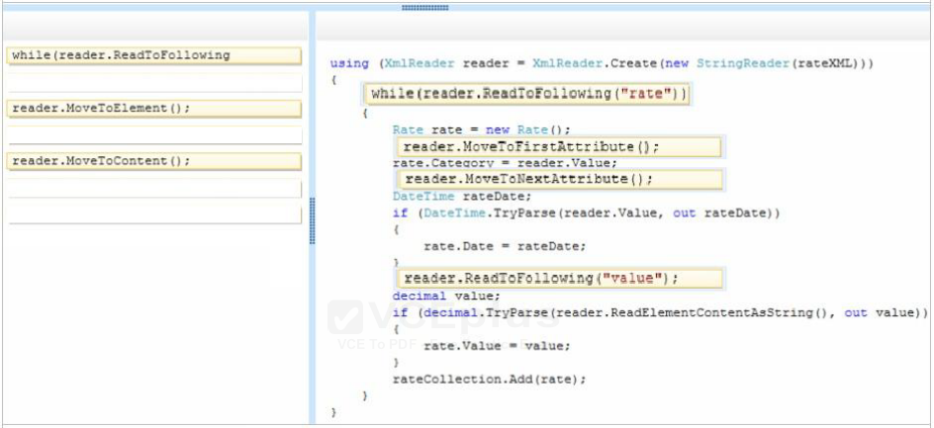

You are developing an application that will write string values to a file. The application includes the following code segment. (Line numbers are included for reference only.)  
01 protected void ProcessFile(string fileName, string value)

02 {  
3  
04 }  
You need to ensure that the ProcessFile() method will write string values to a file.  
Which four code segments should you insert in sequence at line 03?

**StreamWriter streamWriter = null;  
streamWriter = new StreamWriter(path);  
streamWriter.Write (“value”);  
streamWriter.Close();**

You need to write a console application that meets the following requirements:  
If the application is compiled in Debug mode, the console output must display Entering debug mode.  
If the application is compiled in Release mode, the console output must display Entering release mode.  
Which code should you use?

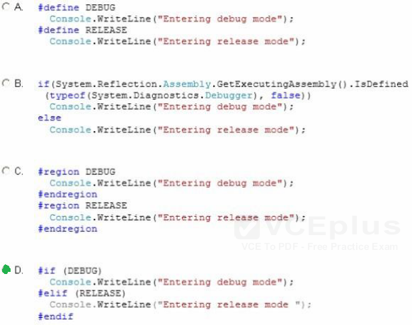

You are developing an application by using C#. The application will write events to an event log. You plan to deploy the application to a server.  
You create an event source named AppSource and a custom log named AppLog on the server. You need to write events to the custom log.  
Which code segment should you use?

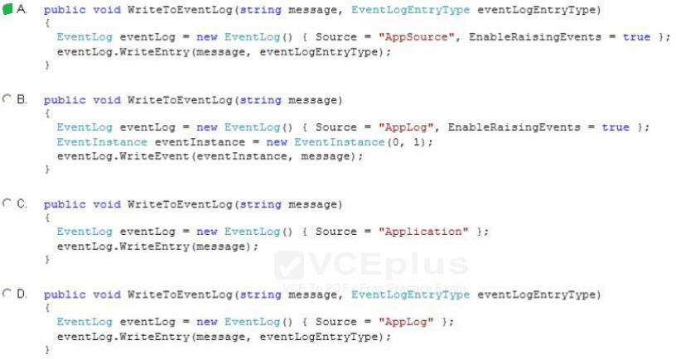

You are developing a C# application. The application includes the following code segment, (Line numbers are included for reference only.)

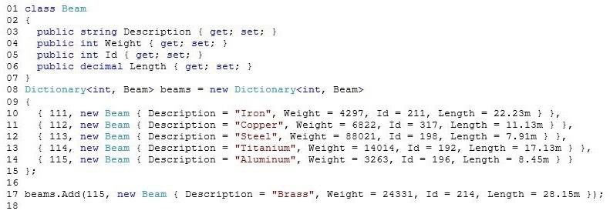  
The application fails at line 17 with the following error message: “An item with the same key has already been added.”  
You need to resolve the error.  
Which code segment should you insert at line 16?

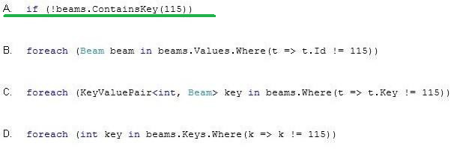

You are developing an application by using C#. The application includes a method named SendMessage. The SendMessage() method requires a string input.  
You need to replace “Hello” with “Goodbye” in the parameter that is passed to the SendMessage() method.  
Which two code segments can you use to achieve this goal? 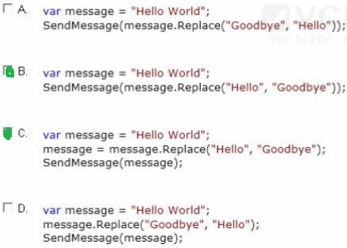

You are developing an application that includes the following code segment:

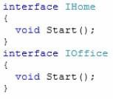  
You need to implement both Start() methods in a derived class named UseStart that uses the Start() method of each interface. Which two code segments should you use?

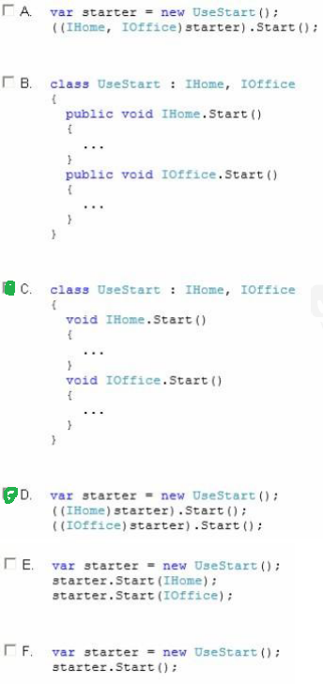

You are developing an application that will use multiple asynchronous tasks to optimize performance.  
You create three tasks by using the following code segment. (Line numbers are included for reference only.)

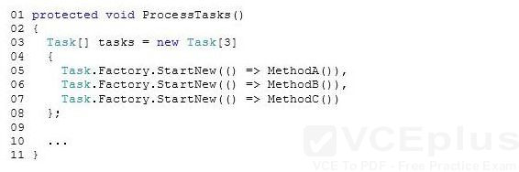  
You need to ensure that the ProcessTasks() method waits until all three tasks complete before continuing.  
Which code segment should you insert at line 09? **Task.WaitAll(tasks);**

You are evaluating a method that calculates loan interest. The application includes the following code segment. (Line numbers are included for reference only.)

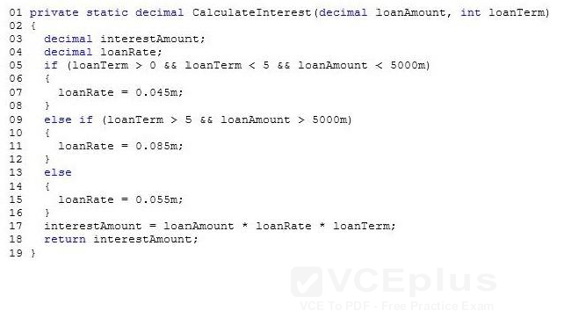  
When the loanTerm value is 5 and the loanAmount value is 4500, the loanRate must be set to 6.5 percent.  
You need to adjust the loanRate value to meet the requirements.  
What should you do? **Replace line 15 with the following code segment: loanRate = 0.065m;**

You are developing an application that includes a class named Customer and a generic list of customers. The following code segment declares the list of customers:  
List customersList = new List () ;  
You populate the customersList object with several hundred Customer objects.  
The application must display the data for five Customer objects at a time.  
You need to create a method that will return the correct number of Customer objects.  
Which code segment should you use?

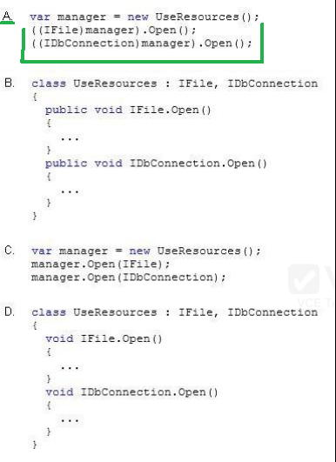

**public static IEnumerable Page(this IEnumerable source, int page, int pageSize)  
{  
return source.Skip((page – 1) * pageSize).Take(pageSize);  
}**

You are debugging a 64-bit C# application.  
Users report System.OutOfMemoryException exceptions. The system is attempting to use arrays larger than 2 GB in size. You need to ensure that the application can use arrays larger than 2 GB.  
What should you do? **Set the value of the gcAllowVeryLargeObjects property to true in the application configuration file.**

You develop an application by using C#. The application counts the number of times a specific word appears within a set of text files. The application includes the following code. (Line numbers are included for reference only.)

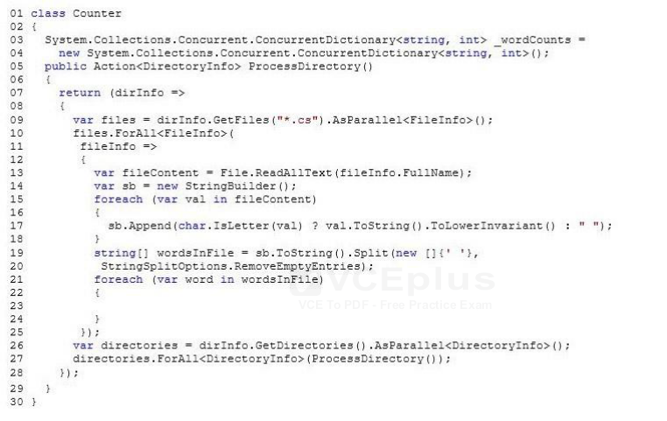  
You have the following requirements:  
Populate the _wordCounts object with a list of words and the number of occurrences of each word.  
Ensure that updates to the ConcurrentDictionary object can happen in parallel.  
You need to complete the relevant code.  
Which code segment should you insert at line 23?

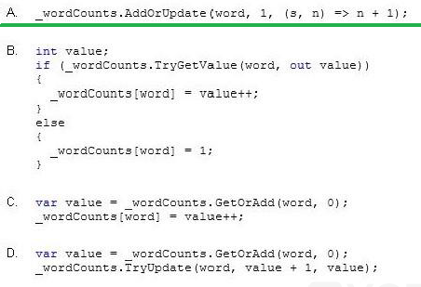

You are developing an application that will be deployed to multiple computers. You set the assembly name.  
You need to create a unique identity for the application assembly.  
Which two assembly identity attributes should you include in the source code?  **AssemblyCultureAttribute**  
 **AssemblyVersionAttribute**

You are developing an application that contains a class named TheaterCustomer and a method named ProcessTheaterCustomer. The ProcessTheaterCustomer() method accepts a TheaterCustomer object as the input parameter.  
You have the following requirements:  
Store the TheaterCustomer objects in a collection.  
Ensure that the ProcessTheaterCustomer() method processes the TheaterCustomer objects in the order in which they are placed into the collection.  
You need to meet the requirements.  
What should you do? **Create a System.Collections.Queue collection. Use the Enqueue() method to add TheaterCustomer objects to the collection. Use the Dequeue() method to pass the objects to the ProcessTheaterCustomer() method.**

You are creating an application that processes a list of numbers.  
The application must define a method that queries the list and displays a subset of the numbers to the user. The method must not update the list. You need to create an extendable query by using LINQ.  
What should you do?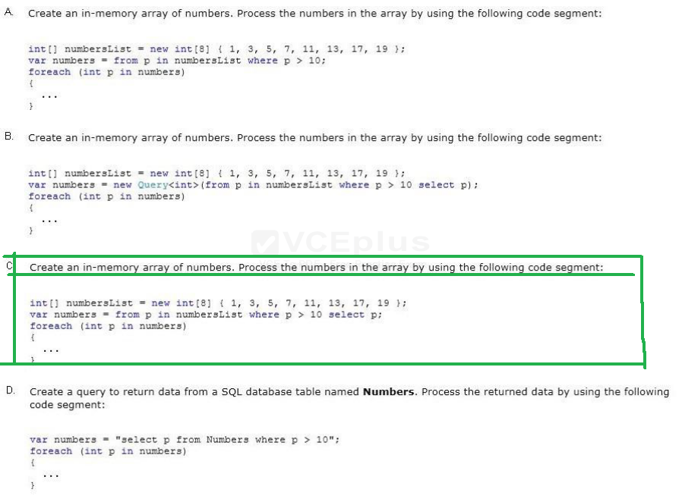

You are developing an application that includes methods named EvaluateLoan, ProcessLoan, and FundLoan. The application defines build configurations named TRIAL, BASIC, and ADVANCED.  
You have the following requirements:  
The TRIAL build configuration must run only the EvaluateLoan() method.  
The BASIC build configuration must run all three methods.  
The ADVANCED build configuration must run only the EvaluateLoan() and ProcessLoan() methods.  
You need to meet the requirements.  
Which code segment should you use?

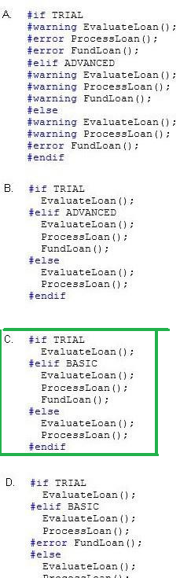

You are creating a console application named App1.  
App1 retrieves data from the Internet by using JavaScript Object Notation (JSON). You are developing the following code segment (line numbers are included for reference only):

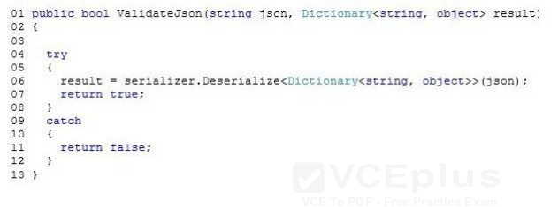  
You need to ensure that the code validates the JSON string. Which code should you insert at line 03?

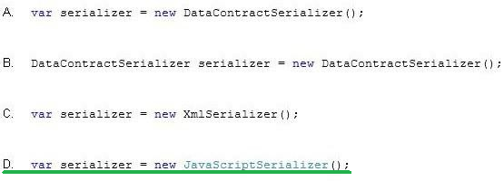

You are creating a class named Loan.  
The Loan class must meet the following requirements:  
Include a member that represents the rate for a Loan instance.  
Allow external code to assign a value to the rate member.  
Restrict the range of values that can be assigned to the rate member.  
You need to implement the rate member to meet the requirements.  
In which form should you implement the rate member? **public property**

You are creating a class library that will be used in a web application.  
You need to ensure that the class library assembly is strongly named.  
What should you do? **Use the AL.exe command-line tool**

You have the following code:

  
You need to retrieve all of the numbers from the items variable that are greater than 80.  
Which code should you use?

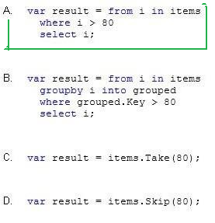

You are implementing a method named GetValidPhoneNumbers. The GetValidPhoneNumbers() method processes a list of string values that represent phone numbers.  
The GetValidPhoneNumbers() method must return only phone numbers that are in a valid format. You need to implement the GetValidPhoneNumbers() method.  
Which two code segments can you use to achieve this goal? (Each correct answer presents a complete solution. Choose two.)

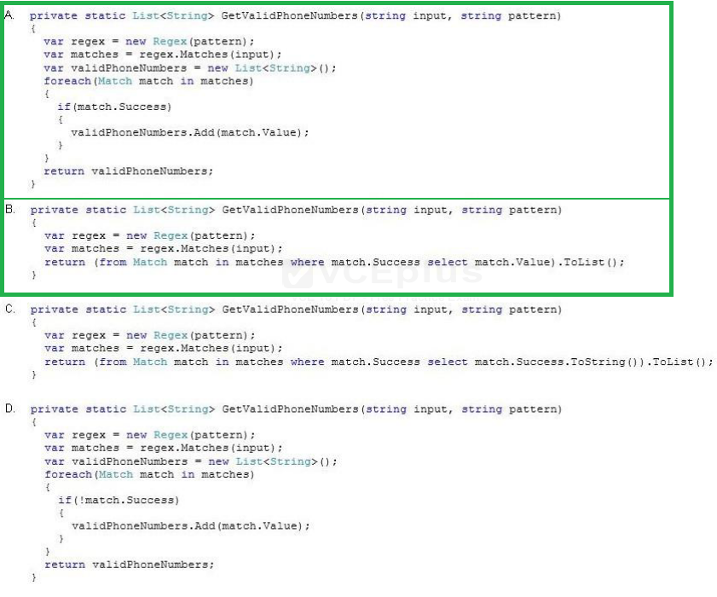

You are developing an application that will write data to a file. The application includes the following code segment. (Line numbers are included for reference only.)  
You need to ensure that the WriteData() method will write data to a file.  
Which four code segments should you insert in sequence at line 03? (To answer, move the appropriate code segments from the list of code segments to the answer area and arrange them in the correct order.)  
Select and Place:

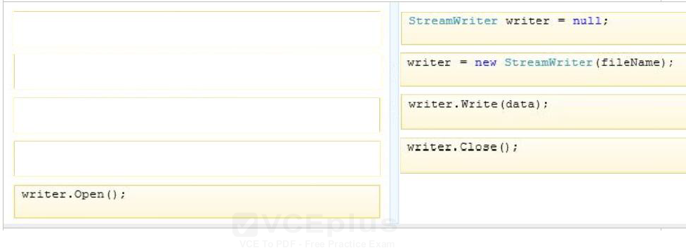

You need to create a method that can be called by using a varying number of parameters.  
What should you use? **method overloading**

You are creating an application that reads from a database.  
You need to use different databases during the development phase and the testing phase by using conditional compilation techniques. What should you do?  **Configure the Define DEBUG constant setting in Microsoft Visual Studio.**

You are developing an application in C#.  
The application uses exception handling on a method that is used to execute mathematical calculations by using integer numbers. You write the following catch blocks for the method (line numbers are included for reference only):

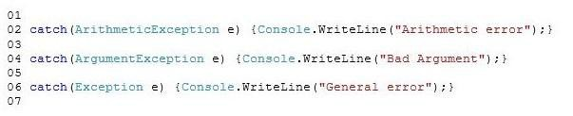  
You need to add the following code to the method:

  
At which line should you insert the code? **01**

You are developing an application that uses multiple asynchronous tasks to optimize performance. The application will be deployed in a distributed environment.  
You need to retrieve the result of an asynchronous task that retrieves data from a web service. The data will later be parsed by a separate task.  
Which code segment should you use?

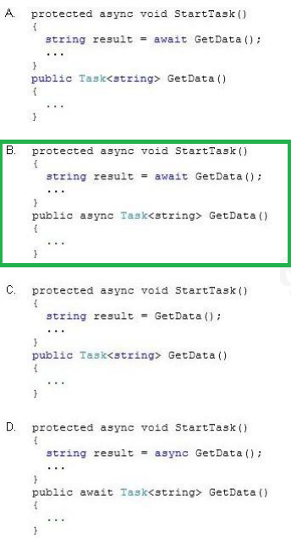

You are implementing a method named ProcessData that performs a long-running task. The ProcessData() method has the following method signature: public void ProcessData(List values, CancellationTokenSource source, CancellationToken token)  
If the calling code requests cancellation, the method must perform the following actions:  
Cancel the long-running task.  
Set the task status to TaskStatus.Canceled.  
You need to ensure that the ProcessData() method performs the required actions.  
Which code segment should you use in the method body? **token.ThrowIfCancellationRequested();**

You have the following code (line numbers are included for reference only):

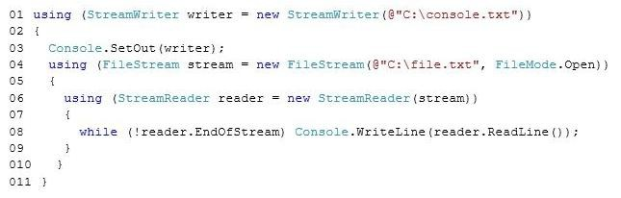  
To answer, complete each statement according to the information presented in the code.

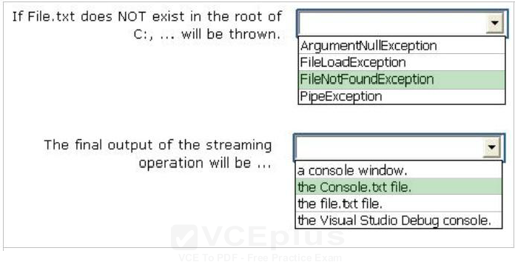

You are developing a method named GetHash that will return a hash value for a file. The method includes the following code. (Line numbers are included for reference only.)

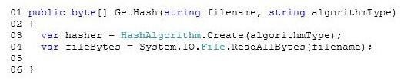  
You need to return the cryptographic hash of the bytes contained in the fileBytes variable.  
Which code segment should you insert at line 05?

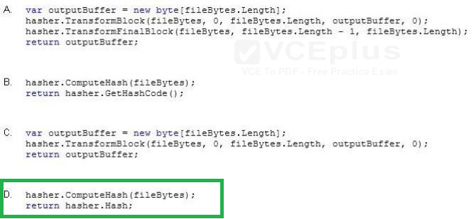

You are developing an application that includes the following code segment:

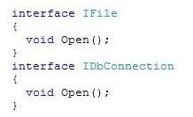  
You need to implement the Open() method of each interface in a derived class named UseResources and call the Open() method of each interface.  
Which two code segments should you use? (Each correct answer presents part of the solution. Choose two.)

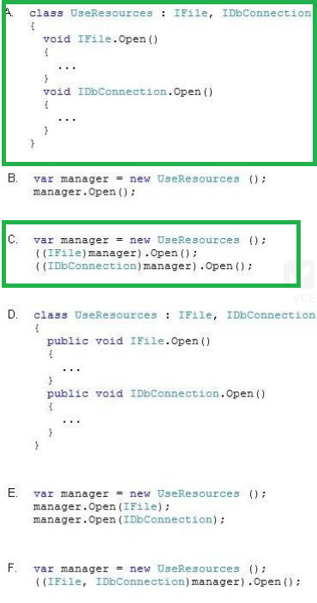

You are adding a method to an existing application. The method uses an integer named statusCode as an input parameter and returns the status code as a string.  
The method must meet the following requirements:  
Return “Error” if the statusCode is 0.  
Return “Success” if the statusCode is 1.  
Return “Unauthorized” if the statusCode is any value other than 0 or l.  
You need to implement the method to meet the requirements.  
How should you complete the relevant code? (To answer, drag the appropriate statements to the correct locations in the answer area. Each statement may be used once, more than once, or not at all. You may need to drag the split bar between panes or scroll to view content.)  
Select and Place:

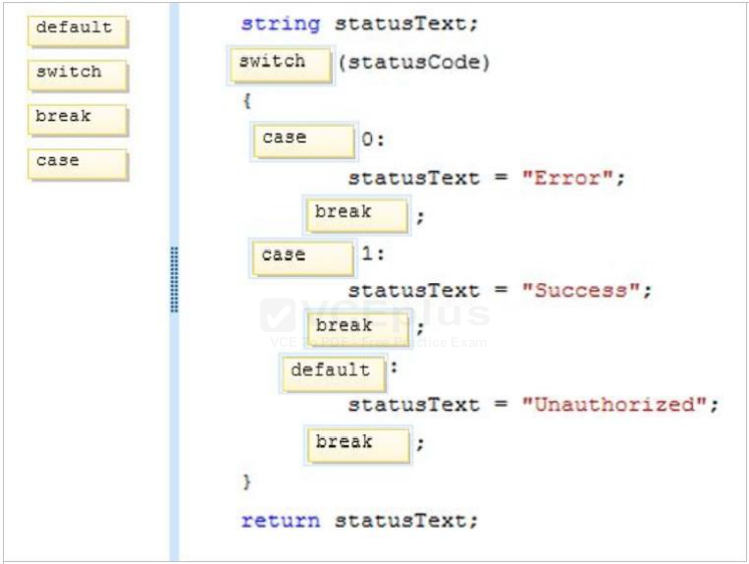

You have the following class (line numbers are included for reference only):

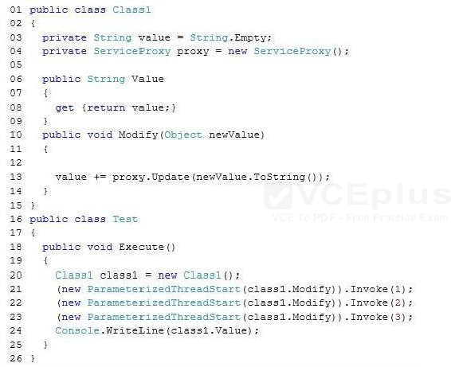  
ServiceProxy is a proxy for a web service. Calls to the Update method can take up to five seconds. The Test class is the only class the uses Class1. You run the Execute method three times, and you receive the following results:  
213  
312  
231  
You need to ensure that each value is appended to the Value property in the order that the Modify methods are invoked.  
What should you do?

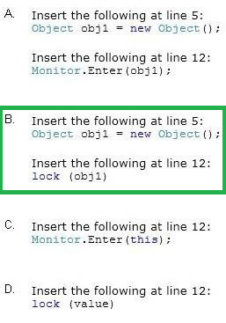

You need to write a console application that meets the following requirements:  
If the application is compiled in Debug mode, the console output must display Entering debug mode.  
If the application is compiled in Release mode, the console output must display Entering release mode.  
Which code should you use?

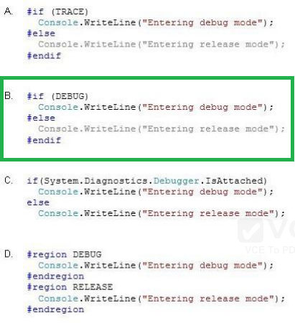

You have an existing order processing system that accepts .xml files,  
The following code shows an example of a properly formatted order in XML:

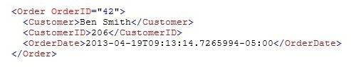  
You create the following class that will be serialized:

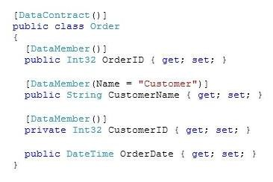  
For each of the following properties, select Yes if the property is serialized according to the defined schema. Otherwise, select No.  
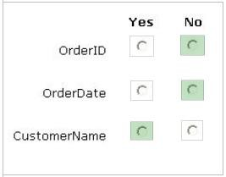

You are developing an application that includes methods named ConvertAmount and TransferFunds.  
You need to ensure that the precision and range of the value in the amount variable is not lost when the TransferFunds() method is called.  
Which code segment should you use?

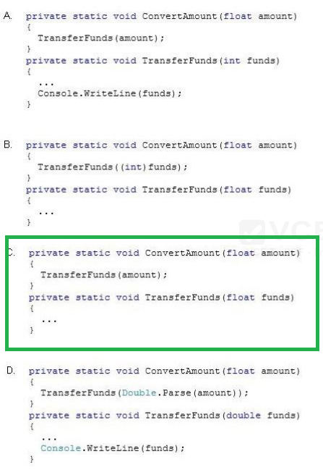

You are developing a class named Account that will be used by several applications.  
The applications that will consume the Account class will make asynchronous calls to the Account class to execute several different methods. You need to ensure that only one call to the methods is executed at a time.  
Which keyword should you use? **Lock**

You are developing an application by using C#. The application will write events to an event log. You plan to deploy the application to a server.  
You create an event source named MySource and a custom log named MyLog on the server. You need to write events to the custom log.  
Which code segment should you use?

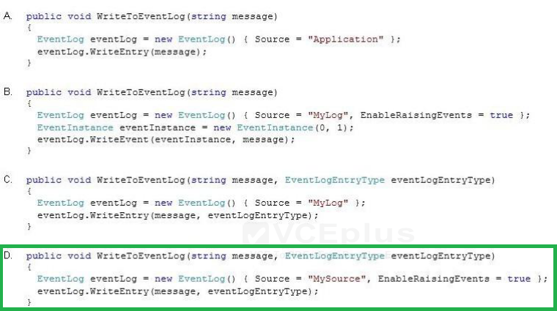

You plan to store passwords in a Windows Azure SQL Database database.  
You need to ensure that the passwords are stored in the database by using a hash algorithm, Which cryptographic algorithm should you use?  **SHA-256**

You are implementing a new method named ProcessData. The ProcessData() method calls a third-party component that performs a long-running operation to retrieve stock information from a web service.  
The third-party component uses the IAsyncResult pattern to signal completion of the long- running operation so that the UI can be updated with the new values.  
You need to ensure that the calling code handles the long-running operation as a System.Threading.Tasks.Task object to avoid blocking the UI thread. Which two actions should you perform? (Each correct answer presents part of the solution. Choose two.)  **Create a TaskCompletionSource<T> object. *oraz* Call the component by using the TaskFactory.FromAsync() method.**

You write the following method (line numbers are included for reference only):

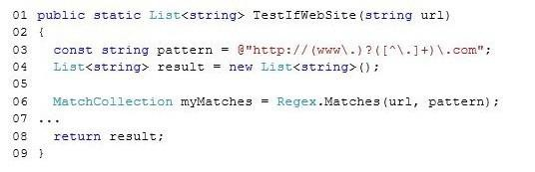  
You need to ensure that the method extracts a list of URLs that match the following pattern:  
@http://(www.)?([^.]+).com;  
Which code should you insert at line 07?

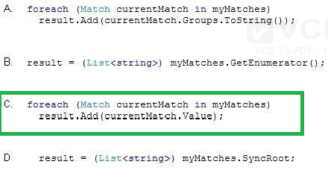

You have the following code:

  
You need to retrieve all of the numbers from the items variable that are greater than 80.  
Which code should you use?

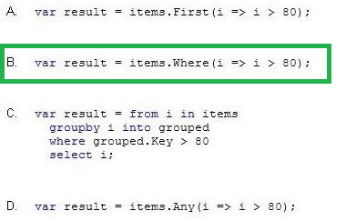

You are developing an application that uses several objects. The application includes the following code segment. (Line numbers are included for reference only.)

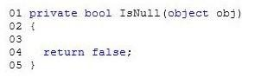  
You need to evaluate whether an object is null.  
Which code segment should you insert at line 03?

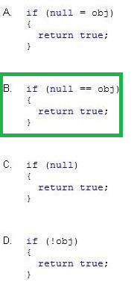

You have the following code (line numbers are included for reference only):

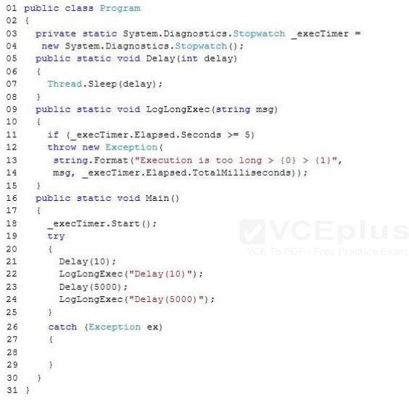  
You need to ensure that if an exception occurs, the exception will be logged.  
Which code should you insert at line 28?

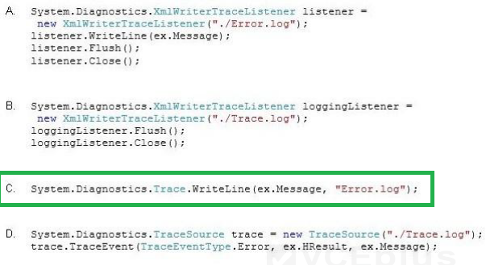

You are troubleshooting an application that uses a class named FullName. The class is decorated with the DataContractAttribute attribute. The application includes the following code. (Line numbers are included for reference only.)

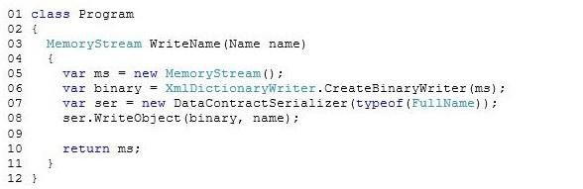  
You need to ensure that the entire FullName object is serialized to the memory stream object.  
Which code segment should you insert at line 09? **binary.Flush();**

You are developing an assembly.  
You plan to sign the assembly when the assembly is developed.  
You need to reserve space in the assembly for the signature.  
What should you do? **Add the AssemblyDelaySignAttribute attribute to the assembly.**

You have an application that accesses a Web server named Server1.  
You need to download an image named Imagel.jpg from Server1 and store the image locally as Filel.jpg.  
Which code should you use?

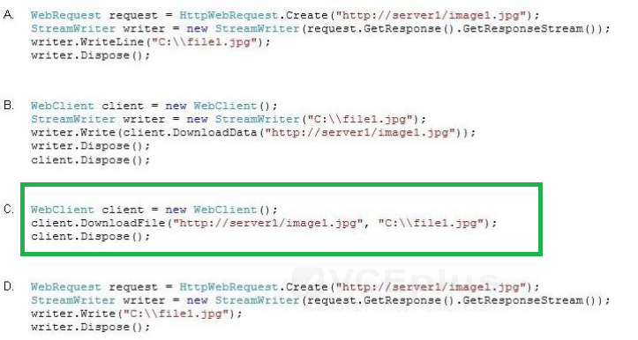

You are developing a C# application. The application references and calls a RESTful web service named EmployeeService. The EmployeeService web service includes a method named GetEmployee, which accepts an employee ID as a parameter. The web service returns the following JSON data from  
the method.  
{“Id”:1,”Name”:”David Jones”>  
The following code segment invokes the service and stores the result:

  
You need to convert the returned JSON data to an Employee object for use in the application.  
Which code segment should you use?

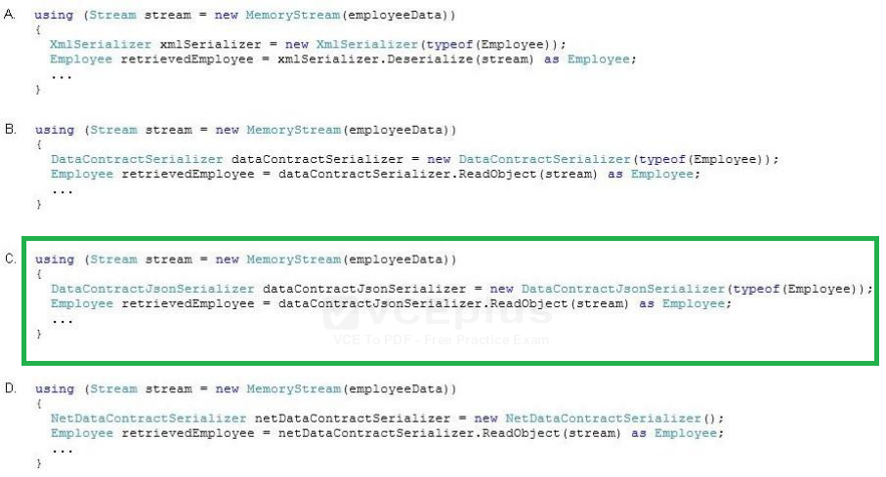

You are developing an application that includes a method named SendMessage.  
You need to ensure that the SendMessage() method is called with the required parameters.  
Which two code segments can you use to achieve this goal? (Each correct answer presents a complete solution. Choose two.)

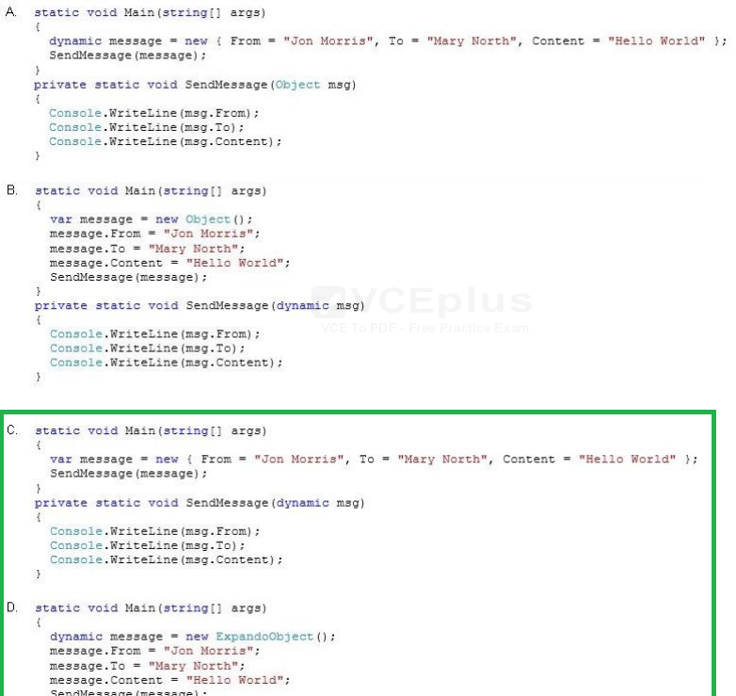

You are developing an application.  
The application contains the following code:

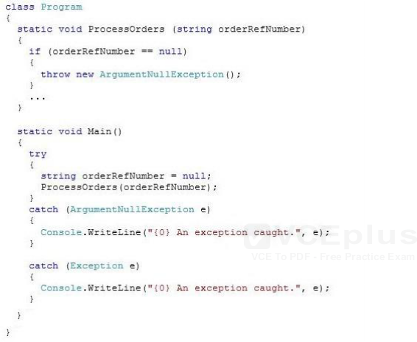  
When you compile the code, you receive the following syntax error message: “A previous catch clause already catches all exceptions of this or a super type (‘System.Exception’).”  
You need to ensure that the code can be compiled. What should you do?  **Catch the ArgumentNullException exception first.**

You have a method that will evaluate a parameter of type Int32 named Status.  
You need to ensure that the method meets the following requirements: If Status is set to Active, the method must return 1.  
If Status is set to Inactive, the method must return 0.  
If Status is any other value, the method must return -1.  
What should you do? (To answer, drag the appropriate statement to the correct location in the answer area. Each statement may be used once, more than once, or not at all. You may need to drag the split bar between panes or scroll to view content.)  
Select and Place:

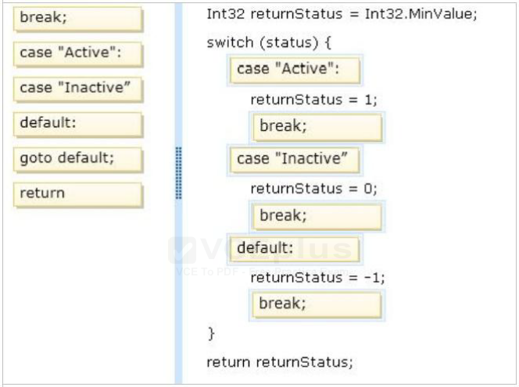

You are developing an application that uses multiple asynchronous tasks to optimize performance.  
You need to retrieve the result of an asynchronous task.  
Which code segment should you use?

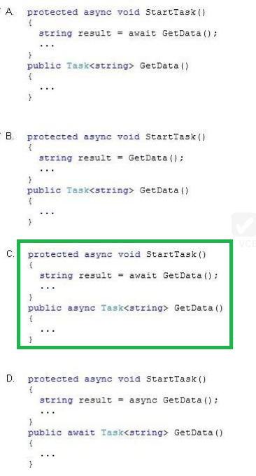

You create an assembly named Assembly1.dll.  
You need to ensure that Assembly1.dll can be deployed to the global assembly cache (GAC).  
Which commands should you run? (To answer, drag the appropriate programs to the correct locations. Each program may be used once, more than once, or not at all. You may need to drag the split bar between panes or scroll to view content.)  
Select and Place:

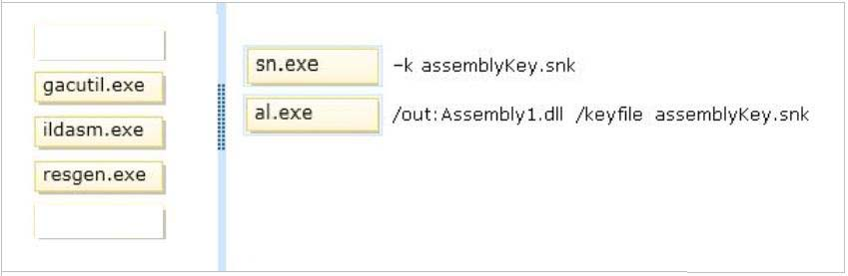

You have an application that accesses a Microsoft SQL Server database.  
The database contains a stored procedure named Proc1. Proc1 accesses several rows of data across multiple tables.  
You need to ensure that after Proc1 executes, the database is left in a consistent state. While Proc1 executes, no other operation can modify data already read or changed by Proc1. (Develop the solution by selecting and ordering the required code snippets.  
You may not need all of the code snippets.)  
Select and Place:

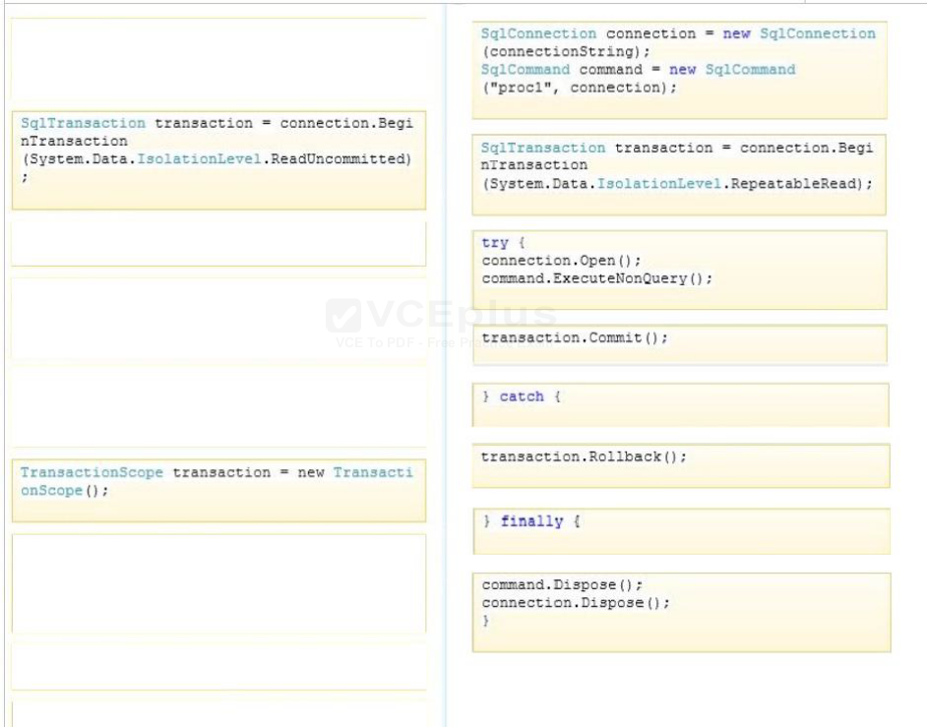

You have an application that uses paging. Each page displays 10 items from a list.  
You need to display the third page. (Develop the solution by selecting and ordering the required code snippets. You may not need all of the code snippets.)  
Select and Place:

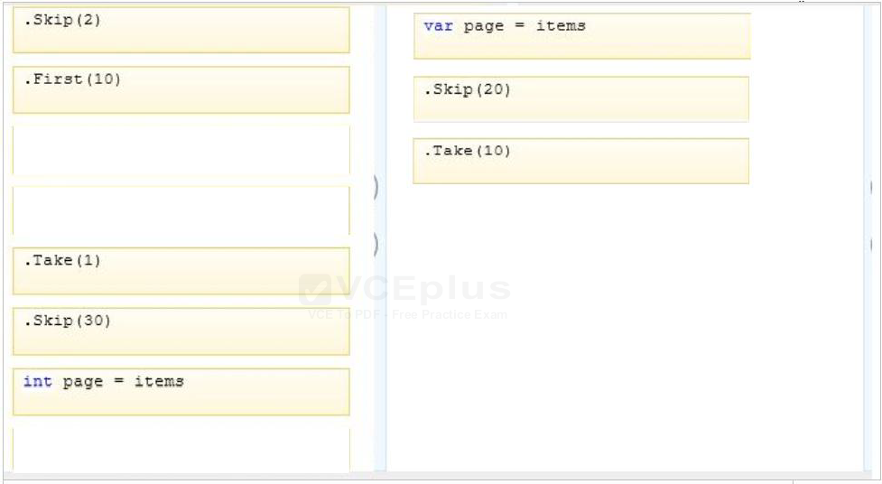

You are developing an application that generates code. The application includes the following code segment. (Line numbers are included for reference only.)

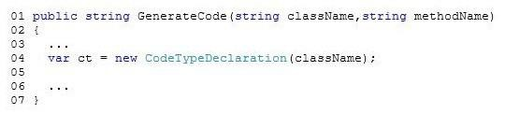  
You need to ensure that code generated by the GenerateCode() method represents a class that can be accessed by all objects in its application domain.  
Which two code segments can you insert at line 05 to achieve this goal? (Each correct answer presents a complete solution. Choose two.)

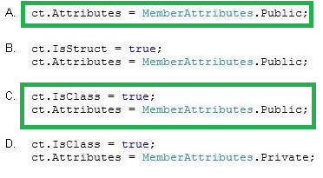

You are developing an application that will process personnel records.  
The application must encrypt highly sensitive data.  
You need to ensure that the application uses the strongest available encryption.  
Which class should you use? **System.Security.Cryptography.TripleDES**

You are developing an application that uses a .config file.  
The relevant portion of the .config file is shown as follows:

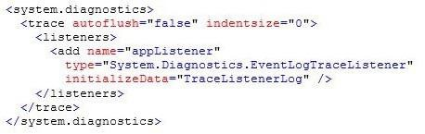  
You need to ensure that diagnostic data for the application writes to the event log by using the configuration specified in the .config file.  
What should you include in the application code?

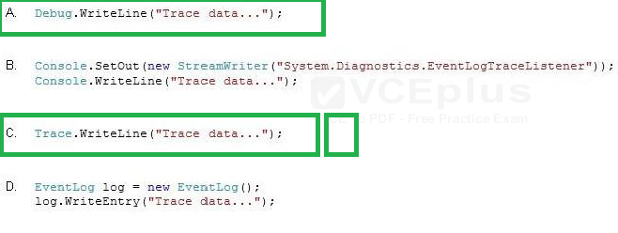

You are developing an application that includes a class named Employee and a generic list of employees. The following code segment declares the list of employees:  
List employeesList = new List();  
You populate the employeesList object with several hundred Employee objects.  
The application must display the data for five Employee objects at a time.  
You need to create a method that will return the correct number of Employee objects.  
Which code segment should you use?

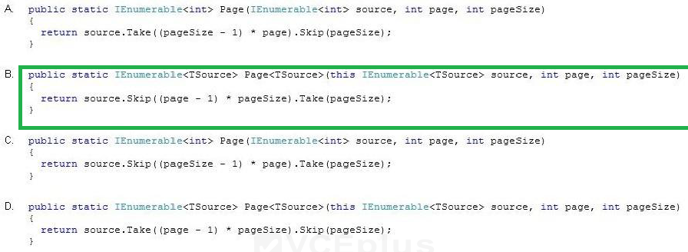

An application contains code that measures reaction times. The code runs the timer on a thread separate from the user interface. The application includes the following code. (Line numbers are included for reference only.)

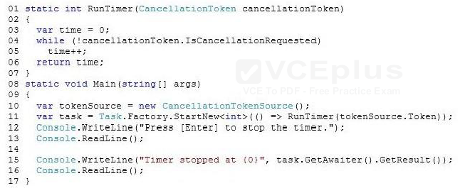  
You need to ensure that the application cancels the timer when the user presses the Enter key.  
Which code segment should you insert at line 14? **tokenSource.Cancel();**

You are implementing a new method named ProcessData. The ProcessData() method calls a third-party component that performs a long-running operation.  
The third-party component uses the IAsyncResult pattern to signal completion of the long- running operation.  
You need to ensure that the calling code handles the long-running operation as a System.Threading.Tasks.Task object.  
Which two actions should you perform? (Each correct answer presents part of the solution. Choose two.) **Call the component by using the TaskFactory.FromAsync() method.***oraz* **Create a TaskCompletionSource<T> object.**

You are developing an application for a bank. The application includes a method named ProcessLoan that processes loan applications. The ProcessLoan() method uses a method named CalculateInterest. The application includes the following code:

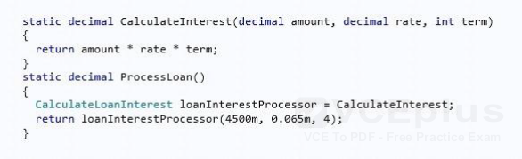  
You need to declare a delegate to support the ProcessLoan() method.  
Which code segment should you use?

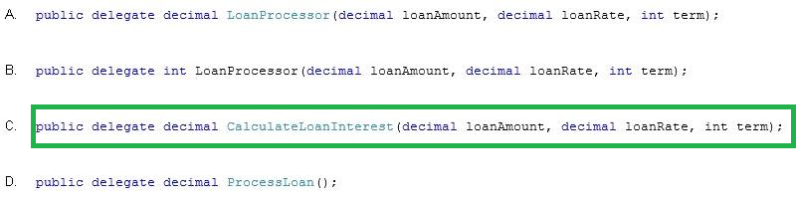

You are modifying an application that processes loans. The following code defines the Loan class. (Line numbers are included for reference only.)

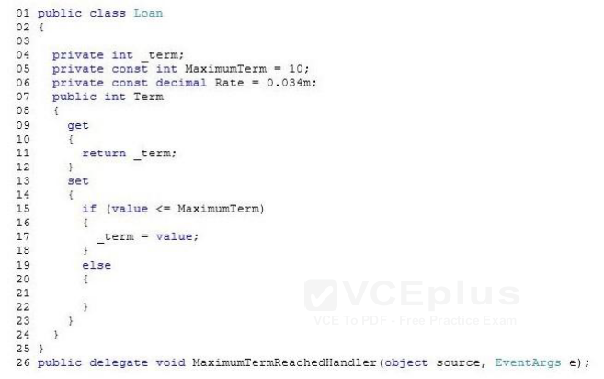  
Loans are restricted to a maximum term of 10 years. The application must send a notification message if a loan request exceeds 10 years.  
You need to implement the notification mechanism.  
Which two actions should you perform? (Each correct answer presents part of the solution. Choose two.)

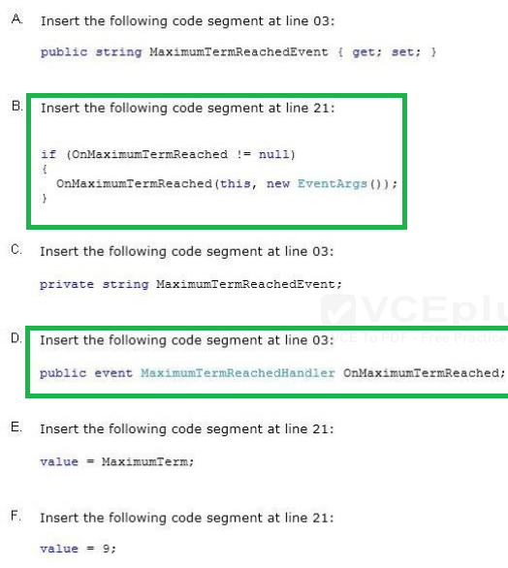

You are evaluating a method that calculates loan interest- The application includes the following code segment. (Line numbers are included for reference only.)

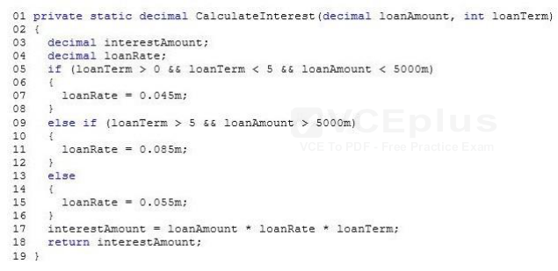  
When the loanTerm value is 3 and the loanAmount value is 9750, the loanRate must be set to 8.25 percent.  
You need to adjust the loanRate value to meet the requirements.  
What should you do? **Replace line 15 with the following code segment: loanRate = 0.0825m;**

You are creating a console application named Appl.  
App1 retrieves data from the Internet by using JavaScript Object Notation (JSON).  
You are developing the following code segment (line numbers are included for reference only):

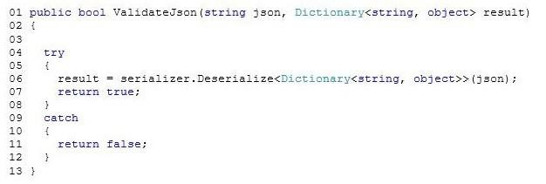  
You need to ensure that the code validates the JSON string. Which code should you insert at line 03?

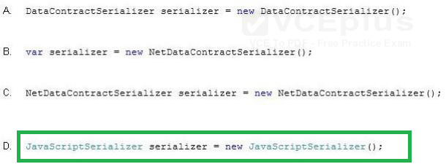

You need to write a method that retrieves data from a Microsoft Access 2013 database. The method must meet the following requirements:  
Be read-only.  
Be able to use the data before the entire data set is retrieved.  
Minimize the amount of system overhead and the amount of memory usage.  
Which type of object should you use in the method?  **DbDataReader**

You have the following code (line numbers are included for reference only):

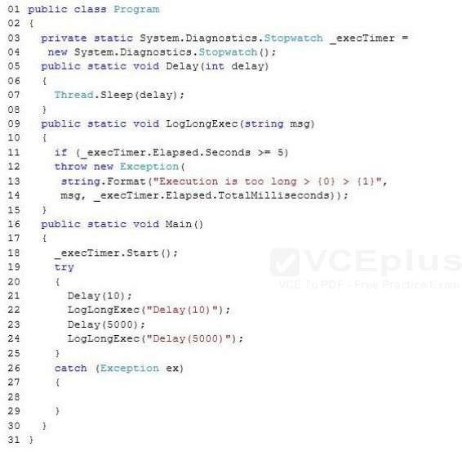  
You need to ensure that if an exception occurs, the exception will be logged.  
Which code should you insert at line 28?

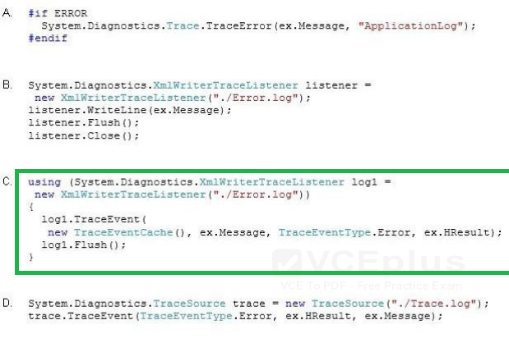

You define a class by using the following code:

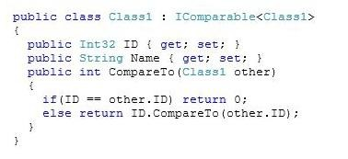  
You write the following code for a method (line numbers are included for reference only):

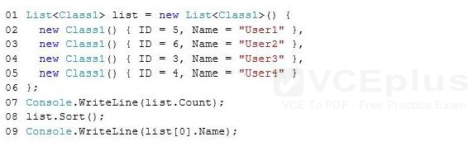  
To answer, complete each statement according to the information presented in the code.  
Hot Area:

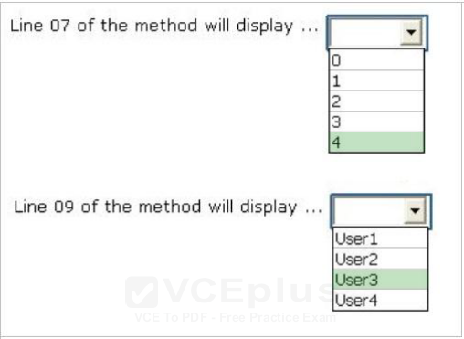

You are creating a console application named App1.  
App1 will validate user input for order entries.  
You are developing the following code segment (line numbers are included for reference only):

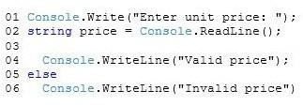  
You need to complete the code segment.  
The solution must ensure that prices are positive and have two decimal places.  
Which code should you insert at line 03?

